R. Reports Menu: 5. Print Animal Renewal Forms

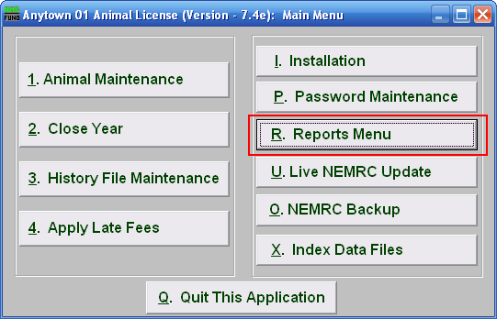
Click on “R. Reports Menu” from the Main Menu and the following window will appear:

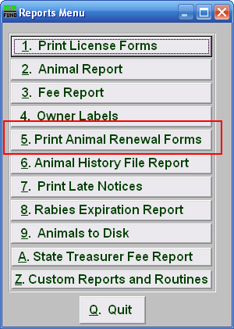
Click on “5. Print Animal Renewal Forms” from the Reports Menu and the following window will appear:

Print Animal Renewal Forms

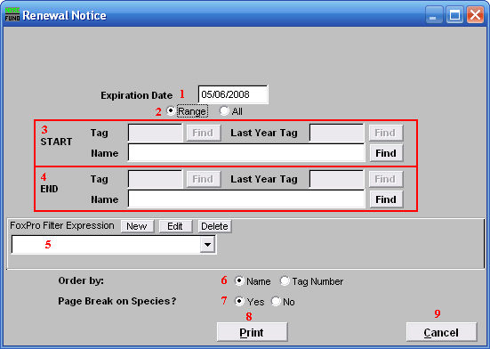
- Expiration Date: Enter the Date of Expiration that the Renewal Notice will show.

- Range OR All: Choose whether this report will be on a Range of, or All animals.

- Start: This is only available if you chose “Range.” Enter the tag number, or last year tag number, of the animal you wish to start with, or click “Find” and select from the Lookup table.

- End: This is only available if you chose “Range.” Enter the tag number, or last year tag number, of the animal you wish to end with, or click “Find” and select from the Lookup table.

- FoxPro Filter Expression: An optional conditional reporting expression developed with NEMRC support. This evaluates animal information to determine if the animal should be included. Contact NEMRC support to learn more about this option.

- Order by: Select whether this report will print in order of owner name or tag number.

- Page Break on Species?: Select if this report will start a new page for each species.

- Print: Click this button to print. Refer to GENERAL PRINTING for more information.

- Cancel: Click “Cancel” to cancel and return to the previous screen.

